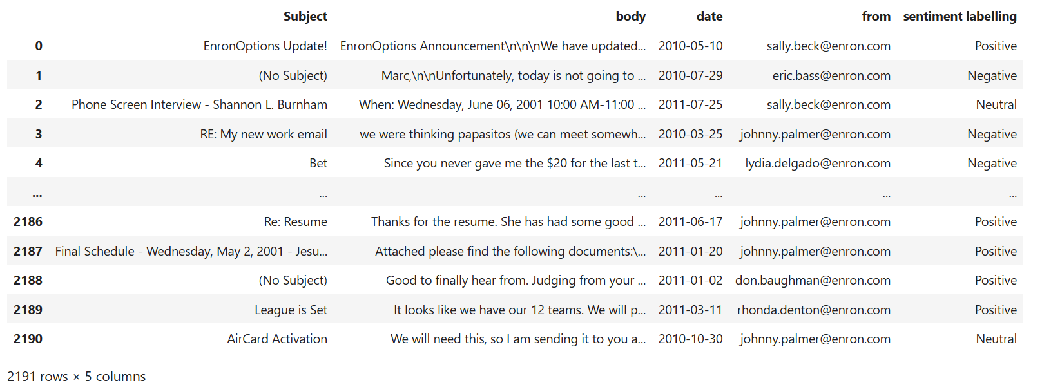

Fig 1 - Dataframe containing labelled sentiments for each text message.

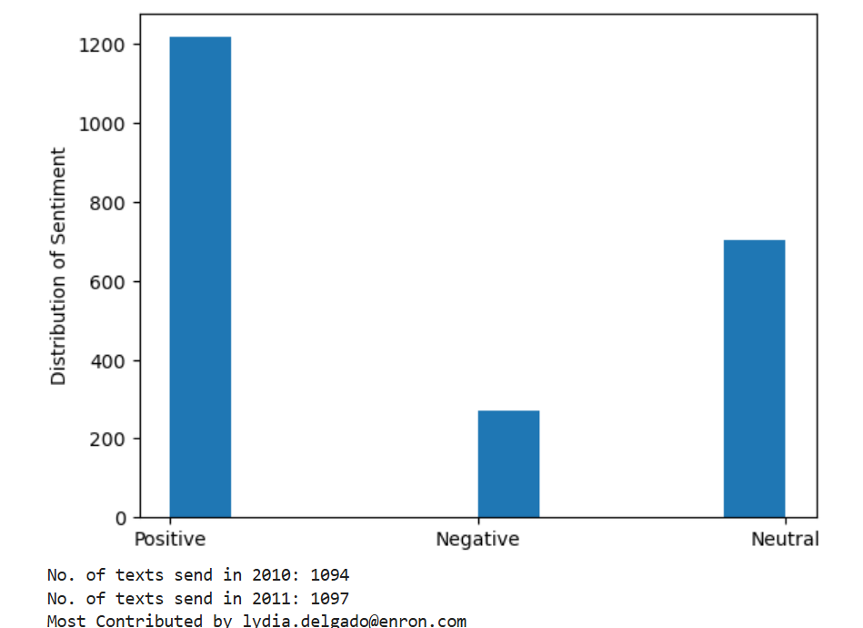

Fig 2 - Exploratory Data Analysis (EDA) containing distribution of sentiment over two years, volume of texts sent in 2010 and 2011, and most and least contributors.

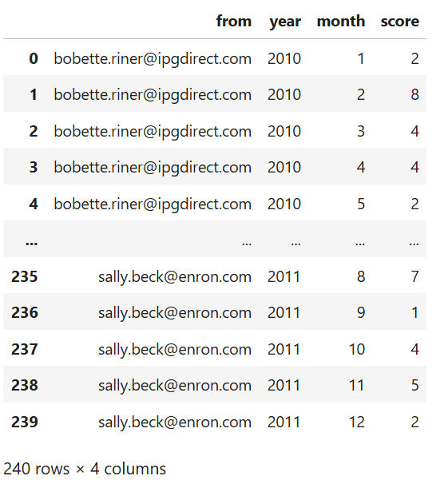

Fig 3 - Average monthly sentiment score of each employee

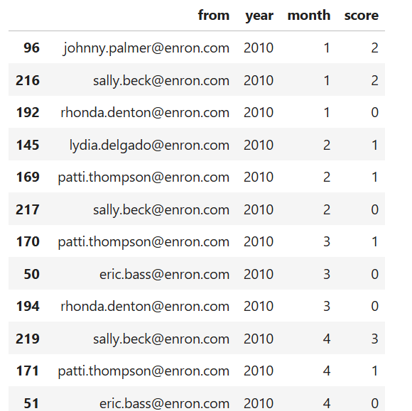

Fig 4 - Employee ranking: bottom three employees each month.

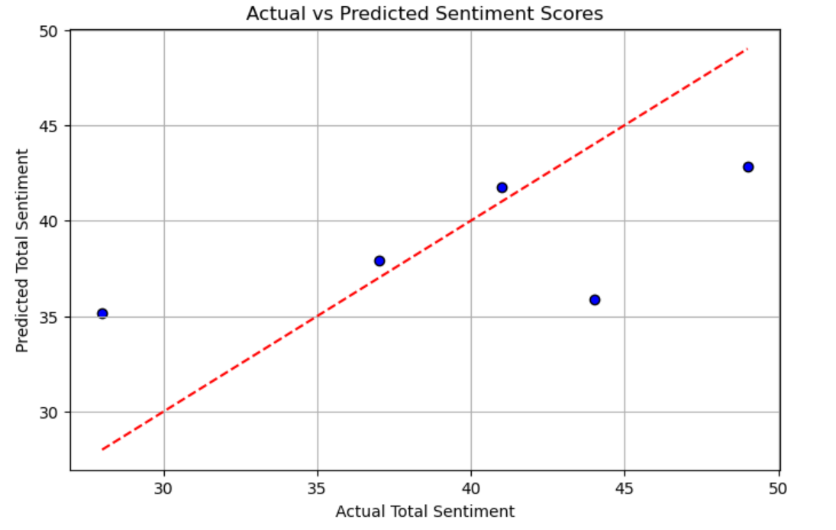

Fig 5 - Performance of Linear Regression model.